MasonryPS23 2023-04-19 1
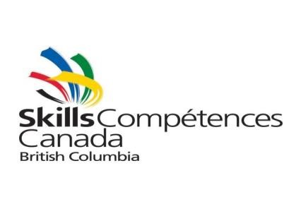
Provincial Scoring Sheet
Masonry (Post-Secondary) 2023
Wednesday April 19, 2023 at:
Abbotsford trade and exhibition centre. 1190 Cornell St, Abbotsford, BC V2T 6H5

Contest Length: 4.5 hours Check-In Time: 09:00 Contest Start: 09:30
Contest Sponsors
Masonry Industry Training Association
Trowel Trades Training Association
Canadian Masonry Contractors Association BC Chapter Masonry Contractors Association of B.C.
International Union of Bricklayers & Allied Craftworkers Local 2 BC Masonry Institute of BC
Purpose of the Challenge:
- To test the knowledge and skill of each student in the Brick Masonry field.
- To prepare each student for employment in the industry.
Skills & Knowledge to be Tested:
• | Safety |  | Level
• | Jointing |  | Gauge
• | Alignment |  | Product Speed
• | Plumb |  | Dimensions
Specific Requirements:
Construct a project wall using Brick and Block according to specifications and diagram.
MasonryPS23 Revised January 27 2023 www.skillscanada.bc.ca

Contestant Name: _________________________________ Skills Place: ____
School/Trainer: _________________________________ Safety Place: ____
Safety Instructions:
Safety awareness/requirements will be maintained at minimum industry standards at all times. A contestant will not be allowed to compete without the safety equipment noted on this document.

Equipment / Tools / Materials
Supplied by Committee:
Safety Glasses, line and line blocks, mortar boards, and all other materials required to complete the
Supplied by Contestant:
Trowel, brick set, concave jointer, joint raker, safety boots (CSA Approved), brick hammer, metric modular tape, brush, level, small piece of carpet.
Judging / Distribution of Marks:
- Level & Plumb 30% ____
- Dimensions (layout, gauge, height) 30% ____
- Details (bond) 10% ____
- Finish & Workmanship Practice (safety, neatness, productivity) 10% ____
- Jointing 15% ____
- Cutting 5% ____
Judged by: Name:________________ Signature:_________________
Name:________________ Signature:_________________
Place:____
Notes:__________________________________________________________

Gold medal winners at the Skills Canada British Columbia Provincial competition may be eligible to compete at the 2023 Skills Canada National Competition on May 25-26, 2023, at the RBC Convention Center, Winnipeg, Manitoba.

MasonryPS23 Revised January 27, 2023 www.skillscanada.bc.ca

