VEX IQ Robotics Competition – SKILLS BC
Purpose of the Event:
To provide BC students with an opportunity to showcase their STEM and robotics skills through a competitive, hands-on VEX IQ Robotics tournament aligned with Skills BC mission to promote skilled trades and technology careers.
Event Overview:
- Competition Format:
VEX IQ Robotics Challenge “Mix & Match” game is played on a 6’ x 8’ rectangular field. Two robots compete in the Teamwork Challenge as an alliance in 60-second-long teamwork matches, working collaboratively to score points. Teams also compete in the Robot Skills Challenge where one robot takes the field to score as many points as possible. These matches consist of Driving Skills Matches, which will be entirely driver controlled, and Autonomous Coding Skills Matches, which will be autonomous with limited human interaction.
- Target Participants:
Elementary and middle school students from across BC, selected through regional qualifiers or direct institutional nomination.
- Event Dates & Venue:
Proposed for April 2026 at the Abbotsford Trade and Exhibition Centre (Tradex), in alignment with the Skills BC Competition schedule.
- Contest Scope Reference: Appendix B
Roles & Responsibilities:
- Host Organization:
  - Coordinate logistics with Skills BC staff
  - Provide volunteers and judges
  - Provide Tournament Manager (TM) software
  - Ensure safety compliance and equipment setup
  - Promote the event to schools and districts
- Skills BC:
  - Provide venue access and infrastructure
  - Table (one per team) and chairs (4 per table)
  - Power – extension cords and power bars for each team table
  - Support registration and communications
  - Promote the event to schools and districts
  - Offer awards and recognition for winners

Technical Requirements:
- Equipment Needed:
  - Each team will supply their own VEX IQ Robotics kits, extra batteries, motors, parts, etc.
  - Each team will supply their own laptops with VEXcode IQ installed for programming.
  - Power – if not supplied by Skills BC, each team will supply own extension cord and power bar.
  - VEX IQ playing field and game elements – iDESIGN/VEX
  - VEX IQ robot license plates – iDESIGN/VEX
  - Scoring table laptop with Tournament Manager installed, printer, ethernet cables, raspberry pi’s (or laptops), displays (2 – 3 TV’s with HDMI).
- Field Setup:
  - 2 competition fields (A, B)
  - 1 or 2 practice fields (C)
  - Pit areas for teams
  - Field Timers for competition fields (laptop’s or TV’s)
  - Reference field setup drawing (Appendix A.)

Safety & Compliance:
- All participants must follow Skills BC safety protocols, including:
  - Wearing proper footwear and eye protection (if necessary)
  - Keeping pit areas tidy
  - Passing robot inspections before competition

Benefits to Students:
- Hands-on experience with robotics and engineering
- Exposure to skilled trades and technology careers
- Opportunity to earn medals, scholarships, and national recognition
- Networking with peers, educators, and industry professionals
Skills Demonstrated:
- Engineering design and iteration
- Programming and automation
- Strategic gameplay and teamwork
- Safety and compliance with competition rules

Appendix A. VEX IQ Event Setup Drawing

Estimated Area: 30’ x 54’ (1620 sq. ft.)
Capacity: 16 - 20 Teams

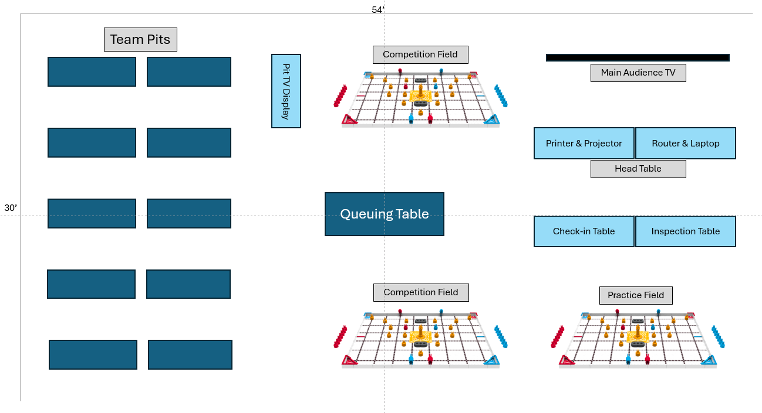

Appendix B. Competition Scope

- GENERAL CONTEST INFORMATION
1.1 Purpose of the Contest
To give competitors the chance to apply both practical and theoretical knowledge while strengthening their STEM skills through hands-on, student-driven learning experiences.

The Game:
VEX IQ Robotics Competition Mix & Match is played on a 6’ x 8’ rectangular field. Two robots compete in the Teamwork Challenge as an alliance in 60-second-long teamwork matches, working collaboratively to score points.

Teams also compete in the Robot Skills Challenge where one robot takes the field to score as many points as possible. These matches consist of Driving Skills Matches, which will be entirely driver controlled, and Autonomous Coding Skills Matches, which will be autonomous with limited human interaction.

The Challenge
The scoring objects in VEX IQ Robotics Competition Mix & Match are Pins and Beams.

The primary objectives of the game are to build Stacks out of Pins and Beams, and Place Stacks in Goals. Additional Pins are introduced to the Field by Drive Team Members at the Load Zone.

Points are awarded based on how many Pins and Beams are Connected, how many colors are included in each Stack, and for Stacks that match the color of the Goal.

The Robot Skills Challenge, one (1) Robot takes the field to score as many points as possible. These matches consist of Driver Skills Matches, which will be entirely driver controlled, and Programing Skills Matches, which will be autonomous with limited human interaction.

The Robot Skills Challenge, and the Teamwork Challenge use the exact same field and set up.

For the complete game manual: https://www.vexrobotics.com/mix-and-match-manual?srsltid=AfmBOoqLdTLzaVdkweFsi9z4C-DubmBSn9TQ2WOhkZV96TM2syDjEndy

Note – The game manual is a live document that will have updates throughout the year, on the following dates:
- October 9, 2025 and December 4, 2025 will include clarification of rules and minor updates.
- January 29th, 2026 may include gameplay or rule changes inspired by mid-season events.
- April 2, 2026, may include gameplay or rule changes pertaining specifically to the VEX Robotics World Championship.
These rule updates/changes will apply to the Skills BC Competition.
Game Overview Video : https://youtu.be/RN-UyJbe_yg

This contest is offered as an official contest.

1.2 Technical Committee

Technical Chair: Richard Seniuk, Innovation First
Contact: Richard_Seniuk@RECF.org

Technical Chair: Andy Fenos, iDESIGN 365 LTD.
Contact: andy@idesign365.com

Technical Chair: Tyler Patriquin, Innovation First
Contact: tyler_patriquin@innovationfirst.com
Co-Technical Chairs: TBD

Skills BC Competitions Department: TBD

Any questions regarding this scope must be sent at least two weeks prior to the contest date to be guaranteed a response.

1.3 Contest Schedule

DATE, 2026
8:30am – 9:00am | Sign-in at challenge site
9:00am – 9:30am | Orientation
9:30am – 2:30pm | Practice Matches (throughout the day - not scheduled)
9:30am – 12:00am | Teamwork Challenge (Qualifications)
12:00pm – 12:30pm | Lunch
12:30pm – 2:15pm | Skills Challenges (Driver and Autonomous)
2:30pm – 3:30 pm | Final Matches
3:30pm – 4:00pm | Disassembly and Clean Up
4:00pm* | Awards Ceremony at the challenge site

*Competitors must be on time for their contest or may be disqualified at the discretion of the Technical Committee.

1.4 Additional Information

- Information regarding rules, regulations, and conflict disputes: https://skillscanada.bc.ca/wp-content/uploads/2025/07/Updated-PoliciesCompetitionRegulations-Revised-June-2025-11.32.11-AM.pdf
- Visitor information such as parking, busses, and hotels: https://skillscanada.bc.ca/competitions/provincial-competitions/2025-spectator-school-bus-subsidy/
- Competition Documents:
https://skillscanada.bc.ca/provincial-competition-documents/
- Information on the sponsors of this contest: https://skillscanada.bc.ca/get-involved/sponsorship-opportunities-customized-sponsorship-packages-become-a-sponsor/sponsors-2025/

- SKILLS AND KNOWLEDGE TO BE TESTED
- Teamwork
- Engineering design process
- Critical thinking
- Project management
- Communication skills
- Collaboration - Discussion of Ideas
- Problem Solving

- JUDGING CRITERIA

Each Connected Pin | 1 point
Each Connected Beam | 10 points
Each 2-color Stack | 5-point bonus
Each 3-color Stack | 15-point bonus
Each Stack Placed in a Matching Goal and/or Connected to a Beam | 10-point bonus
Each Stack Placed on the Standoff Goal | 10-point bonus
Each Cleared Starting Pin | 2 points
Each Robot in contact with Scoring Objects at the end of the Match. | 2 points

Teamwork Challenge
Each Teamwork Challenge Match consists of two teams, operating as an alliance, to score points. The Teamwork Challenge includes Practice, Qualifying, and Finals Matches. After the Qualifying Matches, teams will be ranked based on performance. The top teams will then participate in the Finals Matches to determine the Teamwork Challenge champions. The number of teams participating in the Finals Matches will be determined based on the number of teams participating.
Teamwork Challenge Finals Matches
- At the conclusion of Qualification and Skills Matches, the top teams will advance to the Finals Matches.
- The number of Finals Matches will be determined based on the number of teams participating.
- The first and second ranked teams form an alliance, third and fourth ranked teams form another alliance (and so on) for the Finals Matches.
- Starting with the lowest ranked alliance, each alliance participates in ONE Finals Match. After all the Finals matches are run, the highest score of those matches is the winning alliance. Second highest score finishes in second place, and so on. (If there is a tie, the higher ranked alliance, prior to the Finals Matches, shall be declared to finish higher)

Robot Skills Challenge
In this challenge teams will compete in sixty (60) second long matches to score as many points as possible. These matches consist of Driver Skills Matches, which will be entirely driver controlled, and Programing Skills Matches, which will be autonomous (no VEX IQ controller) with limited human interaction. Each match will consist of only one Robot.
IMPORTANT NOTE – Teams must compete in at least one autonomous AND one driver sixty (60) second long skills match to qualify for a Skills award (Gold, Silver, Bronze).
Robot Skills Challenge Rankings
- For each Skills Match teams are awarded a score based on the above scoring rules.
- Teams will be ranked based on the sum of their highest Programming Skills Match score and Driver Skills Match score.
- THIS RANKING WILL BE USED TO DETERMINE THE OVERALL WINNER.

FOR COMPLETE RULES AND GAME INFO SEE OFFICIAL GAME MANUAL:

For the complete game manual: https://www.vexrobotics.com/mix-and-match-manual?srsltid=AfmBOoqLdTLzaVdkweFsi9z4C-DubmBSn9TQ2WOhkZV96TM2syDjEndy

Game Overview Video : https://youtu.be/RN-UyJbe_yg

Awards will be given to the top teams in Teamwork Challenge. The Gold & Silver medals will be awarded to the winners of the Teamwork Challenge. This medal will be determined by who ranks higher in the Robot Skills Rankings. The Bronze metal will be awarded to one of the second-place winners of the Teamwork Challenge. Only one team will win the bronze metal. This will be determined by who ranks higher in the Robot Skills challenge.
E.G.
Teams A and B win Teamwork Challenge
If Team A has a higher ranking than Team B in the Robot Skills Challenge then Team A wins Gold and Team B wins Silver.
Teams C and D come in second in the Teamwork Challenge. If Team C has a higher ranking in the Robot Skills Challenge, then Team C wins Bronze.
There will be no awards given for overall performance in Robot Skills. The rankings will be used to determine metal placements as explained above…
IT IS VERY IMPORT TO RUN THE ROBOT SKILLS CHALLENGE AS IT WILL DETERMINE THE OVERALL WINNER
TEAMS MUST HAVE A MINIMUM OF 2 MEMBERS AND NO MORE THAN 4
There will be no ties – if the score is even after the contest, the following steps will be used as the tie breaker. A. Removing the Team’s lowest score and comparing the new average score. B. Removing the Team’s next lowest score and comparing the new average score (on through all scores). If the Teams are still tied, the Teams will be sorted by random draw.
Rule infractions will result in appropriate mark deductions at the discretion of the Technical Committee. Any disqualifications will be reviewed by the Director of Competitions.
To learn about the game, how to coach a team, and host a regional event, visit: https://training.recf.org (Free Resource for Teachers).

- EQUIPMENT AND MATERIALS
Supplied by Competitor:
- Computer or laptop with VEXcode IQ Block software installed
- Please ensure you bring your network adapter if your computer does not have one built in
- If devices brought for peripheral tablets (ie drawing tablet)/ computers, must bring a driver that is compatible with Windows 10
- To bring a back-up device if wished. No back-up device will be available/ provided
- VEX IQ Robotic Kit (Robot is to be pre-built)
  - Kit Purchasing Options: VEX IQ Education Kit (228-8899) or VEX IQ Competition Kit (228-7980) at www.idesign365.com
Please note: There will not be an open wifi network available for competitors/teams to connect.
- Refillable water bottle
- Additional snacks (recommended peanut-free)
- Competitors must be dressed in a clean and appropriate manner with no logos other than that of their school/school board.

Optional:
- Competition Add-On Kit PN : (228-3600)
- VIQC Field Kit (Full 6'x8' Field) (228-7396)
- VIQC Mix & Match Game Kit (228-9148)
- Additional VEX IQ parts as required based on Robot design. Call IDESIGN 365 for assistance.

Software download links :
VEXcode IQ Blocks: https://codeiq.vex.com/ (Recommended)
Supplies can be purchased from iDESIGN 365:
www.idesign365.com (search using above part numbers starting with 228-)
Phone: 1-877-730-4770
Email: sales@idesign365.com
DO NOT BRING ANY ITEMS THAT ARE NOT LISTED ABOVE. THIS INCLUDES ELECTRONIC DEVICES SUCH AS PHONES, TABLETS ETC.
Prior to attending the Skills BC Competition, students should be familiar and competent in the use of the tools and equipment listed above as well as safety precautions that should be observed.

Supplied by Skills BC:
- Game Field
- Lunch

- SAFETY
Safety is a priority at the Skills BC Competition. At the discretion of the judges and technical chairs, any competitor can be removed from the competition site for not having the proper safety equipment and/or not acting in a safe manner.
Competitors must show competence in the use of tools and/or equipment outlined in this scope and can be removed at the discretion of the judges and technical chairs if they do not display tool and/or equipment competency.

Competitors must be dressed in a clean and appropriate manner with no logos other than that of their school/school board.

