2026 PROVINCICAL
SKILLS CANADA COMPETITION
Fashion Technology Competition
Wednesday, April 15, 2026
Abbotsford Trade and Exhibition Centre

1] GENERAL INFORMATION
1.1) Purpose of the Challenge
- To assess the contestant’s ability in critical thinking, creative design, pattern making, and sewing construction in the field of women’s apparel design.
- Competitors will design, pattern make, cut and sew a pair of pants for Spring/Summer 2027 with a traditional front fly, a waistband, pockets and accessories.

1.2) Duration of Competition
- The competition day will last 8 hours and 30 minutes. Eight hours are allotted for the actual competition in addition to a 30-minute lunch break. When planning the design details, candidates should consider the time frame of the competition. The entire pair of pants must be completed within 8 hours.
- Set-up for competitors will begin at 6:45 AM with the mandatory orientation session beginning immediately after at 7:15 AM. The competition will then run from 7:45 AM until 4:15 PM with a mandatory lunch break scheduled at 11:45 for 30 minutes. (Competitors will need to clean up their stations prior to lunch break).

1.3) Skills and Knowledge to be tested.
- The contest will focus on practical work. Theoretical knowledge is limited to what is necessary to carry out practical work. Candidates will complete a pair of pants with mandatory elements in the required time.

2] COMPETITION DESCRIPTION OF PROJECT AND TASKS
2.1) Pre-Competition Elements
- Competitors must prepare a coloured fashion illustration of their proposed pants design. Points will be deducted if the fashion illustration is not submitted prior to the orientation.
- Competitors must use the croquis provided on the Skills Canada BC website to complete a front and back technical drawing. It is intended that the drawing be completed directly on the croquis page. The technical drawings must be completed in pencil only (i.e. the competitor must add the selected pocket design drawn during the morning orientation). and must include a waistband, fly front zipper, pockets, top stitching, design details etc. Points will be deducted if the technical drawing is not submitted within 30 mins from the start of the competition.

2.2) During the competition
- Competitors will be provided with a specific pant block. Competitors must NOT alter the following mandatory components of the pant block when creating the pattern. The final construction of these pieces must reflect the dimensions and marking of the pattern, while respecting the cutting instructions.

- NO waistband alteration (no belt loops, no topstitching etc.)
- Fly-front zip (zipper facing and zipper guard included)
- Minimum length of pants is 18cm below knee

PROJECTS THAT DO NOT INCLUDE ALL THE MANDATORY REQUIREMENTS WILL BE MARKED AS INCOMPLETED AND WILL NOT RECEIVE ANY POINTS FOR THE MISSING COMPONENTS

2.3) Design components (level of difficulty and execution of design components will be considered when judging)
- Fabric for pants: Design must incorporate the use of both sides of the fabric. Lining fabric must only be used for the interior of the pants.
- Design must incorporate the transfer or conversion of ALL darts.
- At the beginning of the competition a pocket style and size will be drawn. The pocket will be either a single welt or patch to a specific measurement (this will be drawn during orientation). Measurements will be for the opening of the pocket and not the overall size of the pocket. Competitors must incorporate two symmetrical pockets of this style into their design, updating their technical drawing, pattern pieces, and garment.
  - NOTE: Pockets must be identical but position on garment may vary. Competitors must respect the ballot draw. Incorrect pockets will not be included as an extra design detail.
- Competitors are not permitted to include the style of pocket that was NOT drawn (ex. If patch pockets are selected, the design may not include single welt pockets). Competitors will be deducted points if both styles are included. However, additional pockets of a different style (ex: in-seam, western) or additional pockets of the selected style may be included as extra design details. Mandatory pockets must be placed on the exterior of the pants. Pocket pattern pieces will be assessed.
- Updated technical drawing must be submitted 30 mins after the start of the competition. Points will be lost if the final garment does not match the technical drawing.

****To facilitate the competitors, the choices for the pocket selection will be:
16cm opening for patch pockets OR
14cm opening for single welt pockets, Hight of welt is 1.5cm
To be drawn during the orientation.

- Competitors must include two of the following design components on the body of the pants. (**Design components added to the waist will be evaluated as part of the waistband) Yoke or other design elements, vent(s) or slit(s), tabs, belts, added fullness (e.g. pleats, gathers, tucks), additional pockets, etc. Competitors will identify their design elements (#1 and #2) during orientation on their technical sketches.
- Must use at least two notion(s) provided. (max number per item are (4 additional snaps), (2 zippers), (.5 metre ribbon), (4 buttons). (minimal per item is (2 additional snaps)), (1 zipper), (.30 metre ribbon), (2 buttons).
  - Indicate the two notions and location thereof on your technical design
  - Please note that notions supplies are limited. Please Advise prior to competition date for preparation.
- Appropriate hem treatment for design must be incorporated. (no raw edges)
- All visible seams are finished. (NO raw edges) Acceptable finishes – serged, flat fell, lapped etc.

2.4) Block for pants (this is not a ¼ scale drawing)

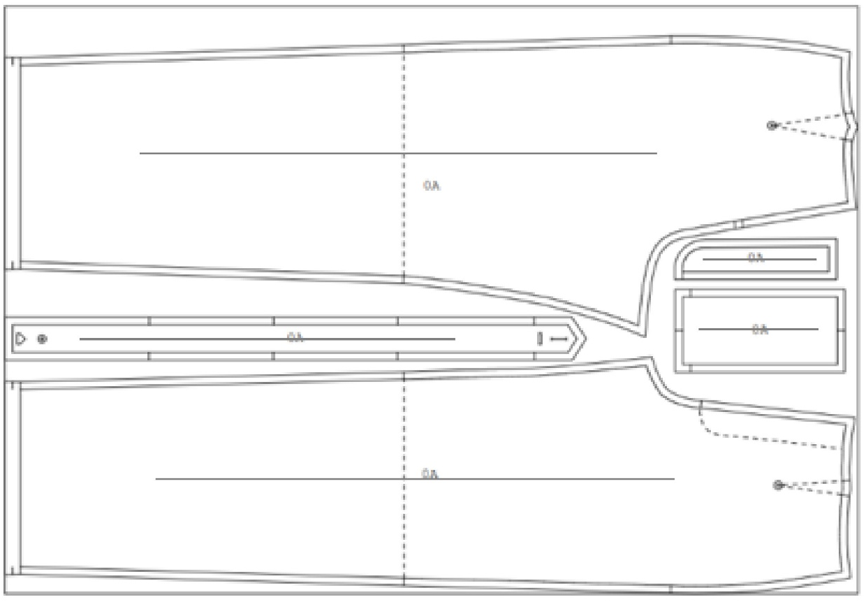

- Block for pants with fly front and waistband includes 1 cm seam allowances and the following pieces.
- Front
- Back
- Fly shield
- Fly facing
- Waistband

3] Material
3.1) Material provided by Skills Canada BC:
- Competitors are limited to items in the supply list. Mandatory template outline (croquis) for technical drawing is available online.

- Pants supplies
- 2 m approximately 145–155 cm wide medium – weight woven (twill/plain weave) fabric (non-stretch or minimal stretch)
- .5 m lining (for pocket lining only) optional
- .5 m interfacing
- Pattern drafting paper
- 1 sew-on hook and eyes (placement as indicated in the pant block).
- 1 sew on button for closure (placement as indicated in the pant block)
- Matching thread
- 1 zipper for closure
- Extra supplies for design elements
  - Snaps - additional
  - Zippers – separating/regular
  - Buttons
  - Ribbons (Mixed)

4] Notes to Competitors
- All work must be identified only by your assigned competitor number, NOT YOUR NAME.
- Competitors must stay inside their assigned workstation area except when using communal equipment (i.e. Sergers, irons, communal supply table).
  - It is prohibited to talk to other competitors.
- NO personal listening devices will be allowed. Use ear plugs if desired.
- Working areas must be kept neat and clean for safety reasons; any messes made by competitors must be cleaned up right away.
  - Marks MAY BE deducted for safety reasons if working areas are not kept neat and clean.
- Competitors MAY NOT use any notions that they bring with them.
- Competitors will be provided with a length of fabric, notions, drafting paper, basic block and thread, at their workstation at the beginning of the day.
- A large garbage bag will be provident for extra paper, fabric scraps (please DO NOT put wet/messy garbage in it as we will be reuse and/or recycling the contain at the end of the competition)

NO REFERENCE MATERIALS OF ANY KIND MAY BE CONSULTED AT ANY POINT DURING THE COMPETITION INCLUDING BREAKS.
All drafting work must be done on the block and drafting paper supplied; all working and finished patterns must be submitted at 11:45 AM. (if competitor still need their pattern pieces, please ask for them) Please separate the pocket pattern pieces, including where the pieces are attached to. These pocket pieces will be marked!

5] Competition Schedule
Times are approximate and subject to change.

6:45 -7:15 AM: Set-up - workstation preparation, machines tested and threaded, set up irons.

7:15 AM: Competition orientation – procedure for the day
- Technical sketches and fashion illustrations collected at this time (Please label your board with your assigned competitor number)
- Expectations and rules etc. questions from competitors.
- Last-minute washroom breaks
- Marshalling area, first aid etc.
- No communication with outside of competition area. (please inform PTC if someone tries to speak to you during competition!)
- Use of the numbers in package (fashion illustrations and technical sketches, pattern package, completed pants.)

7:45 AM: Competition Starts

11:45 AM: Lunch break
- ALL PATTERNS COLLECTED FOR MARKING IN PROVIDED ZIPLOCK BAG
- Competitors must stop working
- Eat lunch, relax, and go to the washroom!

12:15 PM: Competition resumes

4:15 PM: Competition ends
- All garments must be handed in by 4:15 PM on the hangers provided.
- Workstations and surrounding areas must be cleaned up of all items
- Please recycle both paper and fabric into different bins and take home any large remanent fabric/interfacing for future use.

Pack up!
- Clean your station area and return equipment etc. go and enjoy the closing ceremonies.
- Results will be announced in the evening.

6] EQUIPMENT, TOOLS AND SUPPLIES
6.1) Equipment provided by Skills BC
- Domestic ironing board

6.2) Equipment and supplies provided by the competitor
- Sewing machines (domestic, semi-industrial or industrial) Please ensure that you have spare needles, screwdriver etc.
- Sergers (domestic) Please ensure that you have spare needles, screwdriver etc.
- Steam iron and pressing equipment
- Toolkit needed to construct the garment including at least the following: ruler sets, tape measure, pins, hand sewing needles, scissors (fabric and paper), pencils and erasers, marking equipment (chalk, tracing wheel, etc.), seam ripper.
- Toolkit required drawing pattern including at least the following: pencils and erasers, ruler sets, tape measure, scotch tape, felt pens, tracing paper or marking purposes.

7] ASSESSMENT (List is subject to change)

Tasks
Final Fit and Appearance
Creativity and Suitability of Design (this includes fashion illustration and technical drawing)
Sewing of seams, darts, shapes and hem (other than design details #1 &2)
Waistband
Fly: fly facing, fly shield, top stitching
Button attachment and buttonhole placement
Hook and eye
Design element pockets (2X single welt or patch)
Pocket pattern pieces (including the pattern pieces for the placement)
Design details 1
Design details 2
Effective use of notions 1
Effective use of notions 2
Professional Practice (safety)

The illustration and technical drawing will not be marked on its own but must be presented to provide a general impression of what the garment will look like; marks will be deducted if either or both the drawing or illustration is not available.

8] ADDITIONAL INFORMATION
8.1) Ties
If two or more competitors are tied in medal positions, the degree of difficulty for technical elements will break the tie. The Competition Chair will determine medal placings if competitors are still tied.

8.2) Advancement

The Provincial gold medalist will be eligible to represent BC at the 2026 Skills/Competences Canada National Competition in Toronto, Ontario from May 28-29, 2026.

The Skills Canada British Columbia competition rules are applicable in areas not covered by the Scope Document. The Scope Document is the main reference document in running this competition.

